Overview
Fixed assets management system

Version 0.0

Students:
19522467 – Le Thanh Tuan
19520358 – Pham Hieu Vy
19522455- Phung Thanh Tu
Document change record sheet

Date | Version | Description | Authors
25/10/2021 | 0.0 | Initial document. | Phung Thanh Tu, Le Thanh Tuan and Pham Hieu Vy co-operated.
11/12/2021 | 0.0 | Login sequence diagram | Phung Thanh Tu

Table of contents

1. Class diagram (analysis/conceptual level) 3
1.1 Class diagram (analysis level) 3
1.2 List of classes and relationships in Database Module 3
1.3 List of classes and relationships in UI Module and Login Module 4
2. Cohesion and coupling 4
3. State machine diagram (2-3 diagrams) 4

Overview of the system

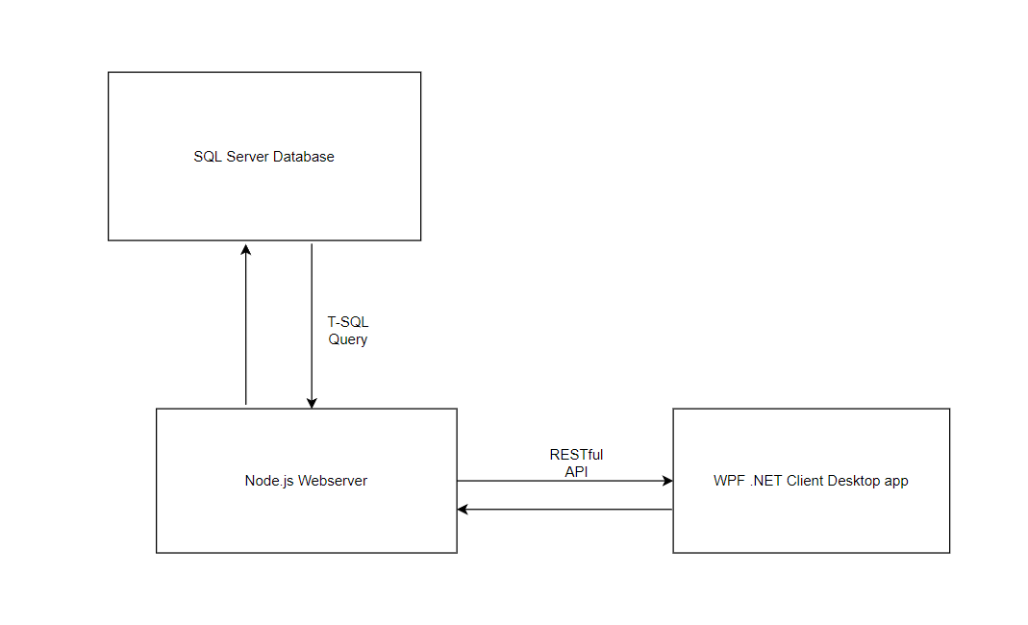
This system consist of 3 parts :
- The SQL Server Database
- The Nodejs Webserver
- The WPF.NET Desktop App
They interact with each other by different protocol :
- The client cannot interact directly with the database
- The client interacts with the webserver by RESTful API with JSON datatype of request/response body.
- The webserver interacts with the database by using Transact-SQL queries.
Please note that this document mainly focuses on the WPF .NET Client because that the database and the webserver are not developed using object oriented programming method so we only specify about database and webserver in just 2 small part of this document.

Database

Database overview
The database of the system is a relational database. It is to store data for the system. Webserver get data from database and send it to the client when required, also update data in the database when client send update information.

Database environment
The database is hosted online, using service of smarterasp.net, with 60day existence. After 60 day, the database will be terminated.
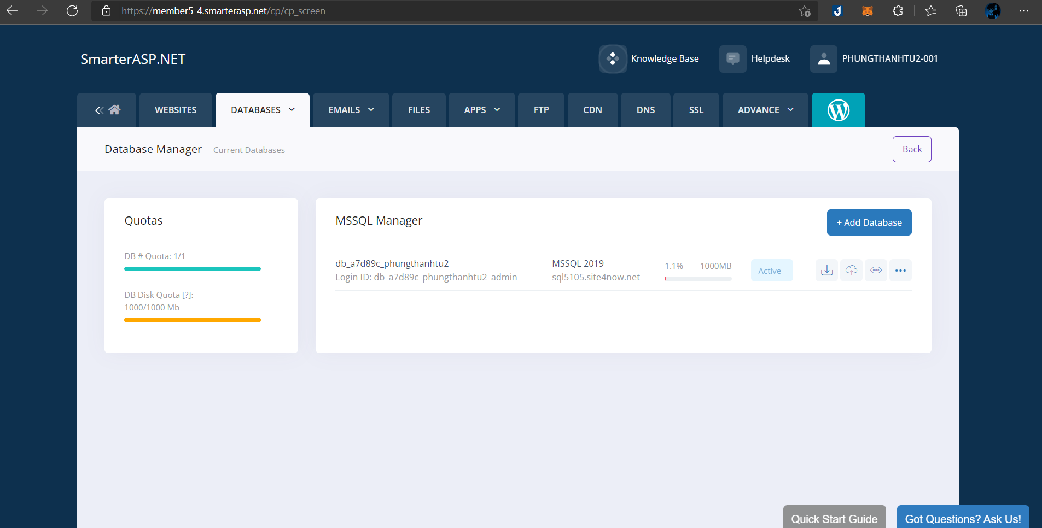
This is a MS SQL Server database, to manage the database directly, we use SQL Server Management Studio.

Database design
This is the design prototype of the database, described by an ERD Diagram
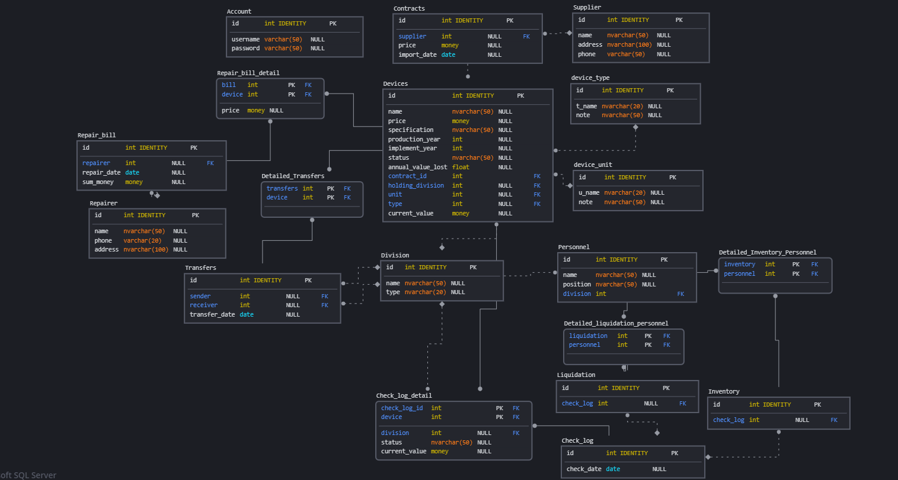

Webserver

Webserver overview
The webserver is the middle part of the system. It’s a bridge to make an interaction between the client and the database. It helps the client to get and send data to the SQL database, using JSON and SQL Query.
It communicates with the client by RESTful web API. Desktop app can using HTTP Request to send and request data from the webserver and then the webserver manipulate request and data in request, then using model to contact with the database to get corresponding data to send back to the client.
The webserver consists of 3 part :
- Model contain module which connect and contact directly with the database through SQL queries
- The Controller handle and manipulate the data and it’s also responsible for sending data to the client.
- The routes define route URIs to specify URI for the client to use.
There’s also an entry module (index.js) which is responsible for setting up the main routes, also the façade of the webserver (all data request from client will be received by this module).

Webserver environment
- Programming language : JavaScript
- Programming framework : Node.js
- Cloud webserver host : Heroku Cloud Platform
- Host domain : https://asset-management-webserver.herokuapp.com/

Webserver design
This is the webserver package diagram :

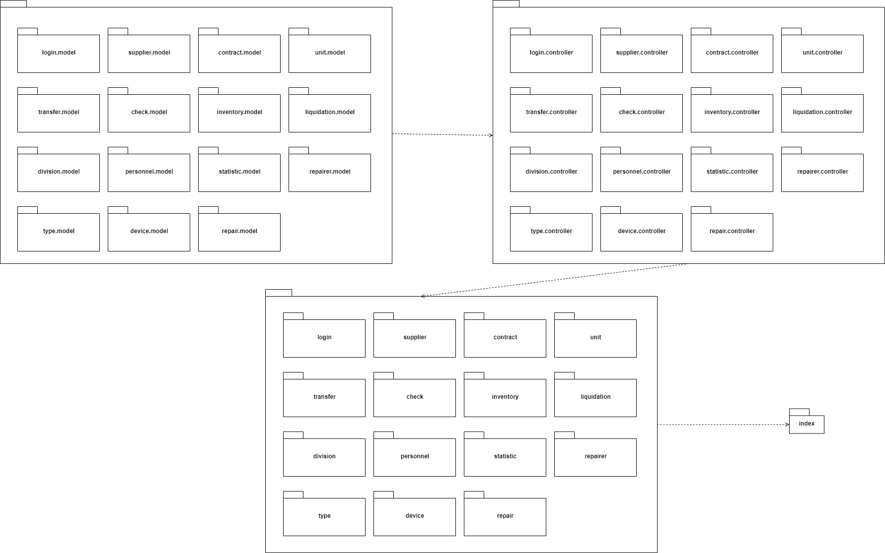
Dependency in this package diagram is simplified. In fact every package routes module uses dependency of its same name controller package, and every controller package uses dependency of its same name model package.

This diagram specify how data is transferred and manipulated in the webserver.
Note that this is the universal for all function of the webserver. We don’t focus on backend in this document so we won’t specify all function, moreover all function uses the same data flow structures.

Data flow for user’s GET request :
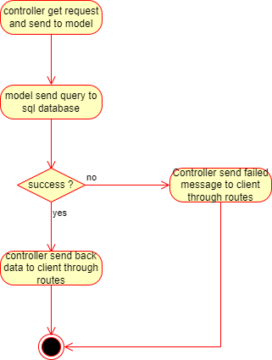
Data flow for user’s POST, PATCH and DELETE request :
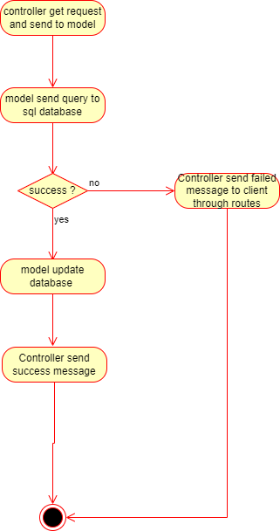

File and folder structure
This is the source folder structure of the webserver
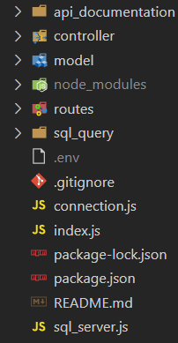
The connection.js is responsible for config database connection.

File structure of controller :
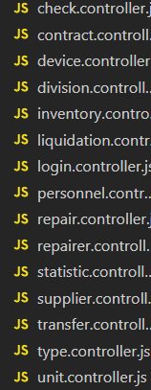
File structure of model :
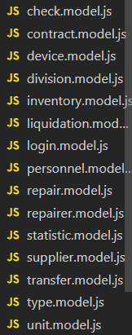
File structure of routes :
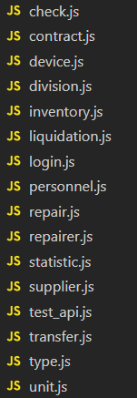

API structure
HTTP method | API Relative URI | Function
GET | /login/:username/:password | Return success message if login success and fail message if login fail
GET | /device/query?division|contract | Get device list by division or contract using URL query
GET | /contract | Get contract list
POST | /device/add | Create new contract with devices
GET | /supplier | Get supplier list
POST | /transfer/add | Transfer devices from division to other division
GET | /transfer/list | Get transfer record list
GET | /transfer/detail/:id | Get transfer device detail by id
GET | /check/list | Get check records
POST | /check/add | Update device status and store result to database
GET | /personnel | Get personnel list
POST | /personnel | Create new personnel
POST | /inventory/add | Create a new inventory
GET | /inventory/list | List inventory records
GET | /inventory/device/:id | List devices in an inventory
GET | /inventory/personnel/:id | List personnels in an inventory
GET | /liquidation/query?division | Get devices which need liquidating in a division
POST | /liquidation/add | Liquidate devices
GET | /liquidation/list | Get liquidation list
GET | /liquidation/devices/:id | Get liquidation device detail by id
GET | /liquidation/personnel/:id | Get liquidation personnel detail by id
GET | /repairer | Get list of repairer company
POST | /repairer | Create new repairer company
GET | /repair/spoiled | Get spoiled devices (need repairing)
GET | /repair/bill | Get repair bills
GET | /repair/detail/:id | Get bill detail by id
POST | /repair/add | Create repair bill and update devices status
GET | /statistic/year_price | Get device repair money by year

